REUNITED 2022
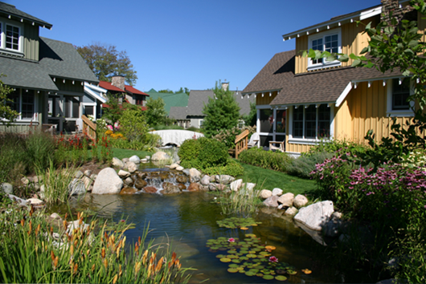
MAPT ANNUAL CONFERENCE
Join us at beautiful Crystal Mountain Resort June 28 – June 30

BUSINESS PARTNER VENDOR SHOW:
TUESDAY JUNE 28, 2022
12:00 – 5:00 SET-UP
5:00-9:00 VENDOR SHOW

Once again, we will have the casino night, food, and beverages included at the same time and in the same location. We will have play money for you to give to the participants, which they then can go and play in the casino. BE CREATIVE when giving them the money!
If you are interested in hosting a hospitality night, Wednesday June 29 is available.
Please consider donating a gift basket to raffle off after the Vendor Show. If you are interested, please email me at morrisk@mapt.org

