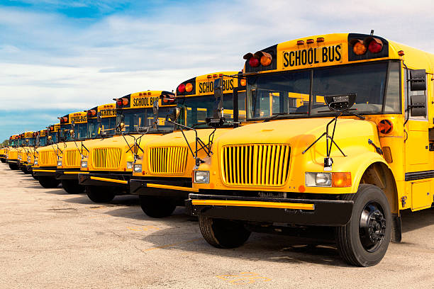

REUNITED 2022
MAPT ANNUAL
PRE-CONFERENCE
Join us at beautiful Crystal Mountain Resort Monday, June 27

Supervisor 6-hour advanced class – Round Table Style
- Facilitated by Mac Dashney
Human Relations for Transportation
- Instructor – Katrina Morris
Garage Facilities Operations
- Instructor – Dave Meeuwsen

